

FANCI and Beta-actin in Figure 10 A

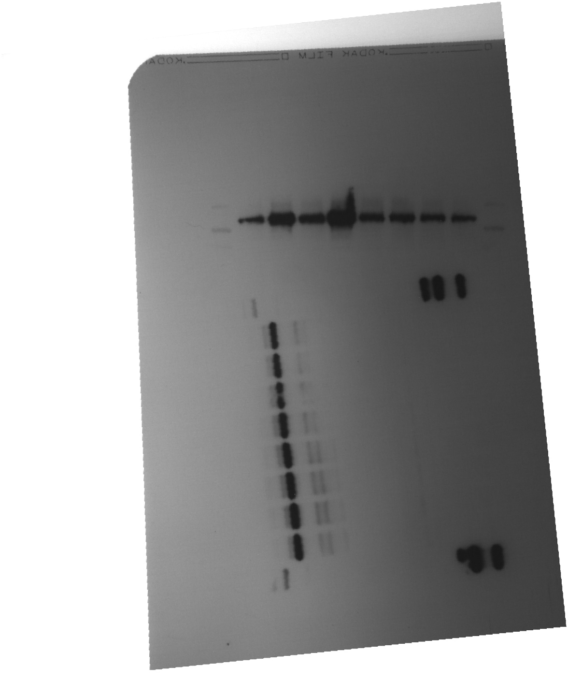

FANCI and beta-actin for figure 10C

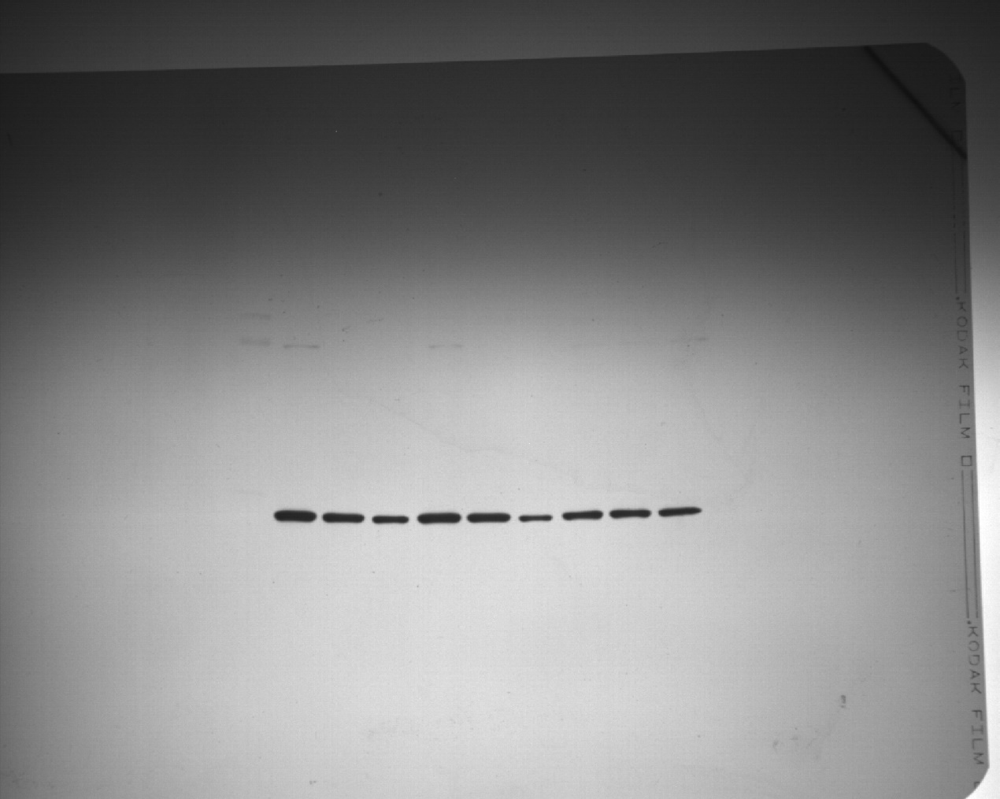

FANCI in Figure 10E

Beta-actin for Figure 10C